CURRICULUM VITAE
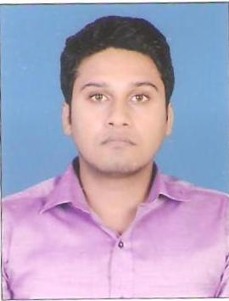
DEEPAKKUMAR NAYAK
C-145, Rajeshwari Society, I.O.C. to Tragad Road
Chandkheda, Ahmedabad, Gujarat - 382470
PHONE : - +91-7567293297, +91-7600795198
Email Id :- deepak0684@gmail.com
PERSONAL PROFILE

Date Of Birth : - 10th August 1990
Nationality :- Indian
Passport No. :- K 5880666 (Ahmedabad)
Software :- MS Office (Word, Excel and PowerPoint), Windows, XP, Auto CAD 2012
Languages : - Hindi, English, Gujarati
CAREER OBJECTIVE

To pursue a career in a company where my inter-personal skills can be utilized to achieve the objective of the organization & which provides me an opportunity of continues learning.
WORK EXPERIENCE

- John Energy Limited :- December 2014 to Present.
Project :- ONGC India Ltd.
( Floorhand / Rigman :- Adding fresh lengths of drill pipe as the drill moves deeper into rock, oversee drilling activites such as well planning, drilling mud program, and BHA configuration, tripping pipe, make fill line line before POOH and operate all valves at BOP manifold as required. Working on 1100HP.)
- GTC Oil Field Services Pvt Ltd :- November 2012 to October 2014.
( Roustabout :- Cleaning, maintaining and repairing the drilling equipment , operation of service rig, moving supplies and equipment to the work site, using lifting gears ropes and winches, mixing the drilling mud to lubricate the drill bit. Worked on 100 Tonne. Project :- ONGC India Ltd.)
EDUCATIONAL QUALIFICATION

Courses | School /  College | Board /  University | Year of  Passing | Class | Percentage
B.TECH.  MECHANICAL | M.E.C.R.C.  Jodhpur | Rajasthan  Technical  University | 2008 - 2012 | FIRST CLASS | 63.38
H.S.C. | Rajasthan  Higher  Secondary  School | GSHEB | 2008 | FIRST CLASS | 63.60
S.S.C | Sabarmati  High  School | GSHEB | 2006 | DISTINCTION | 81.14
TRAINING UNDERTAKEN

- MVT (2015)
- Fire safety and basic fire fighting (2016)
- H.S.E. Rig Pass (2016)
- First Aid (2016)
STRENGHTS AND SKILLS

- The ability to live and work as member of a team.
- Good practical, analytical and presentation skills.
- Awareness of health and safety.
- Adaptable, diligent and keen learner.
I do hereby declare that the particulars and facts stated here in above are true, correct and complete to best of my knowledge and belief.
PLACE :- Ahmedabad (DEEPAKKUMAR NAYAK)
DATE :-

